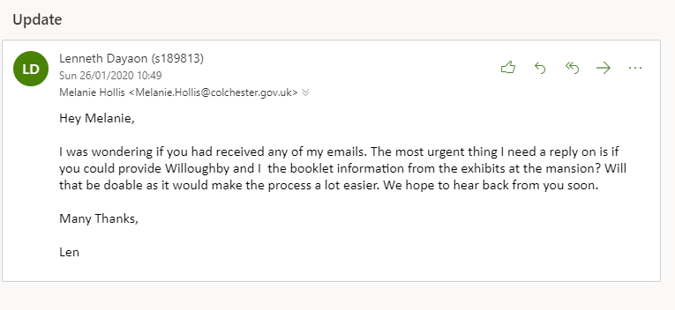

Getting in touch with Melanie as we haven’t heard back from her.

To continue, we communicated this with Adam and on the email below he has provided a contact number to get in touch with her.

It is Tuesday 28th January and I have called her on my phone. Time: 11:50am

We had a conversation and she said that she has been quite busy, but she will be able to send through an email by the end of this week. We also discussed the information booklets that she can provide, and she has requested we get a few specific rooms and get back to her and she will see what she can provide.

